CSCE-310 Database Systems

Homework 10

Raymond Zhu

923008555

Problem 1:

Seven objects were observed

1. RemoteDriverImpl.java
2. RemoteConnectionImpl.java
3. RemoteStatementImpl.java
4. RemoteResultSetImpl.java
5. SimpleConnection.java
6. SimpleStatement.java
7. SimpleResultSet.java

Problem 2:

**Server** **Client**

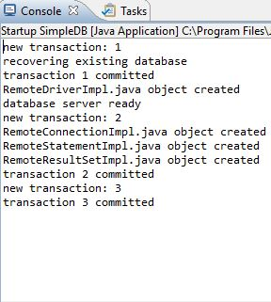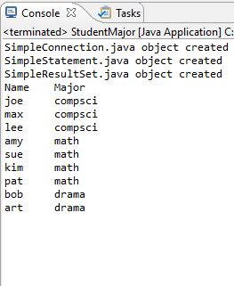

Problem 3:

This is a bad idea because transaction tx is just an incremental value. So, whenever you send in a transaction as a parameter instead of having it done in the method, you could potentially pass wrong values that could potentially break the server. Additionally, certain operations might end up using the same transaction id creating problems for the server but also debugging log files.

For example, if multiple threads were requesting a transaction from the server, passing by parameter could possible put threads and transaction ids out of sync and violate the referential integrity of the database.

Problem 4:

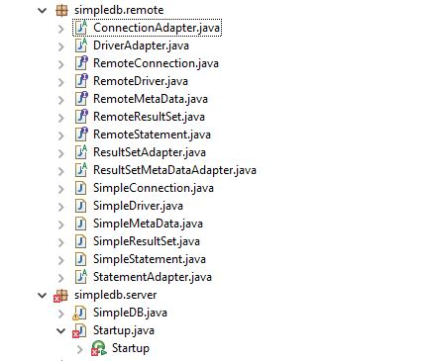

The implementation classes are not necessary for the client (“StudentMajor.java”) to work, however, it is necessary to have the remote interfaces. This is because the interfaces declare the methods and fields that are required at run time when running the client. The implementation itself varies and so that’s why it isn’t necessary.

An Aggie does not lie, cheat, steal, or tolerate those who do.